English Title
First Author^{*1}, Second Author²
1. ………………
2. ………………

Abstract: (Maximum 200 words)
The abstract generally consists of the research topic, methodology, and results, and lengthy introductions should be avoided. (Abstract text goes here...). The abstract should be concise and factual.
(Abstract text... Abstract text... Abstract text...)

Keywords: (3 to 5 words) Keywords contain three to five important terms related to the research variables or topic, intended to help other researchers find the article via search engines.

1. Introduction
The introduction should present theoretical foundations along with a literature review in a coherent, integrated, and continuous manner to clearly define the research topic, the problem statement, and the research gap. The author's goal in this section is not to list citations separately and unrelatedly, but to narrate a scientific flow and highlight the existing void.

2. Materials and Methods
In the research methodology, the author should avoid general statements and definitions regarding research methods. Instead, they should explain in detail how data were collected and analyzed to achieve the research objective(s) or address the scientific gap mentioned in the introduction. These explanations must be precise enough that any reader can replicate the steps and reach the same results if needed. The Study Area can also be introduced in this section. However, if detailed explanations are necessary, the author may create a separate heading titled "Study Area Introduction" and place it in an appropriate location, typically before Materials and Methods.

3. Results
In the Results section, only findings related to the research objectives should be presented. Avoid discussing the research method, literature, or any topic that distracts the reader. If the results are extensive, classify them systematically and explain them under appropriate subheadings. Use appropriate tables and charts in your explanations.

4. Discussion and Conclusion
The final section of the paper is the Conclusion. This section is not a summary or a repetition of the results; rather, the author issues a definitive judgment based on the discussion conducted. In other words, the results have now passed through the evaluation filter called "Discussion," and their impact and application have been determined. If the author feels that the research can be improved, its generalizability expanded, or new models achieved based on the experience gained, they can offer their suggestions in this section.

5. Acknowledgments
If the author(s) received financial support from a specific organization or institution, or wish to thank individuals who assisted in writing the paper, this should be mentioned in the Acknowledgments section.

References
This conference has selected the APA (American Psychological Association) style as the standard for citation.
In this style, the author's name and publication year are cited in the text. If a direct quote is used, the page number follows.
Book:
Author, A. A. (Year of Publication). Title of work: Capital letter also for subtitle. Publisher.
Article:
Author, A. A., & Author, B. B. (Year of Publication). Title of article. Title of Periodical, Volume(Issue), pages. https://doi.org/xx.xxx/yyyy
Website:
National Center for Drought and Crisis Management (2017). Meteorological drought status report of the country for the crop year 2016-2017. Retrieved from: http://ndc.irimo.ir/far/index.php

Formatting Guidelines: The manuscript must be prepared using Times New Roman font. The Main Body text should be written in size 11. The Abstract text should be size 11 (Bold). The Main Title must be set to size 14 (Bold), and Subheadings to size 12 (Bold). Table and Figure captions should be size 11 (Bold); Table contents and Footnotes should be written in size 10. References should be listed in size 11.

Table 1. Sample table
Column 1
Row 1

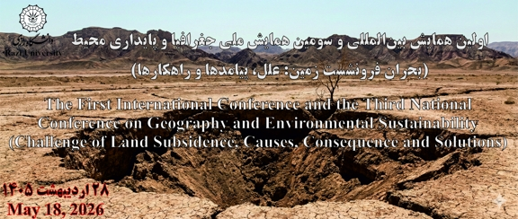
Figure 1. Sample figure (Maps, figures, images, etc. should be included in the figure caption)

